

**Vocational Training Authority of Sri Lanka**

**Gas booking system**

Software Requirement Specification

Submitted by:

K.N Madushan – JL/22/ICT5/1/0032

Submitted to:

…….…………………………..

(Supervisor’s signature)

**Mr. Nishantha Gamage**

Date of submission

2022/08/12

**Table of Content**

1. Introduction 3

1.1 Purpose 3

1.2 Document Convention 4

1.3 Intended Audience and Reading Suggestions 5

1.4 Product Scope 5

1.5 References 5

2. Overall Description 6

2.1 Product Porspective 6

2.2 Product Functions 6

2.3 User Classes and Characteristics 6

2.4 Operating Environment 6

2.5 Design and Implementation Constraints 7

2.6 Project Documentation 7

2.7 User Documentation 8

2.8 Assumptions and Dependencies 8

3. External Interface Requirements 9

3.1 User Interfaces 9

3.2 Hardware Interfaces 10

3.3 Software Interface. 10

4. System Features 11

5. Other Nonfunctional Requirements 13

5.1 Performance Requirements 13

5.2 Safety Requirements. 13

5.3 Security Requirements. 13

5.4 Software Quality Attributes 13

# Introduction

## Purpose

If the SRS is written well it will serve the following purposes. SRS is the agreement document between the client and the Software developer.

**Document Conventions** - This software requirement specification assures the project Management stakeholders and client that the development team has really understood the business requirements documentation properly. This also provides confidence that the team.

**Breaking the Requirements Down**-This document is documented in such a way that it breaks the deliverables into smaller components which makes the participants in this project to understand what is to be done clearly. The information is organized in such a way that all the developers within the team will not only understand the boundaries within which we need to work, but also what functionality needs to be developed and in what order. Understanding what order the functionality will be developed in means that we, the developers will have the "big picture" view of the development. This gives us an opportunity to plan ahead which saves both project time and cost.

**Facilitating other Documentation**-The SRS forms the basis for a load of other important Documents such as the Software Design Specification.

**Product Validation**-It basically helps in validating with the client that the product which is being delivered, meets what they asked for. Which means that the product we have output is Equal to the standards of the documentation in the SRS which the client satisfied and agreed on.

**Characteristics of a Software Requirement Specification**

**1.1.1 Accuracy**

We will ensure the accuracy of the software and the data entered to the database

**1.1.2 Clarity**

This SRS will be clearly stating what the user wants in the software.

**1.1.3 Completeness**

The software requirement specification contains all the requirements stated in the business requirements documentation that the user specified.

**1.1.4 Consistency**

The document is consistent from beginning till the end. It helps the readers understand the requirements well.

**1.1.5 Prioritizations of Requirements**

The requirements will be full filled according to the order of priority and preference.

**1.1.6 Verifiability**

At the end of the project, the user/client will be able to verify that all that all the agreed deliverables have in fact been produced and meet the project management requirements specified.

**1.1.7 Modifiability**

The SRS can be modified when the development team and user feel the need.

**1.1.8 Traceability**

Each requirement stated in the SRS is uniquely associated to a source such as a use case or interaction document etc.

## 1.2 Document Convention

The document is prepared using Microsoft Word 2010 and has used the font type 'Times New Roman'. The fixed font size that has been used to type this document is 12pt with 1.5 line spacing. It has used the bold property to set the headings of the document. All pages except the cover page are numbered, the numbers appear on the lower right hand corner of the page. Every image and data table are numbered and referred to the in the main text Use case scenario is written according to Alistair Cockburn’s template. Standard IEEE template is the template used to organize the appearance of the document and its flow. [k

## 1.3 Intended Audience and Reading Suggestions

The intended audience of this document would be the client and specific employees like Manager and Receptionist, consultants and System Operators of the St Joseph Hospital, and project team, supervisor with the objective to refer and analyze the information. The SRS document can be used in any case regarding the requirements of the project and the solutions that have been taken. The document would final provide a clear idea about the system that is building.

## 1.4 Product Scope

This application is online real estate management through which individual agents or buyer can maintain their property document keeping and managing property registration and also access its information and manage all the adding, updating, deleting the as and some of its tasks. The Admin user can inform their agents regarding property and update the information regarding property and cancellation of property or changing buyer choice.

The system is very useful for companies or builders that can post and edit theirproperties and their personal info and the admin can monitor records of all of them. The

System is also useful which also keeps track of the account details of buyers and owners.

## 1.5 References

[Onile Gas Booking System - Java MySQL Netbeans Projects | FreeProjectz](https://www.freeprojectz.com/java-jsp-netbeans-project/onile-gas-booking-system)

# Overall Description

## 2.1 Product Perspective

**Admin Interface**: Admin is a person who will handle the entire application. That person has to give the user name and password to enter the admin page. After entering the right password admin person can enter the admin home area.

**User’s Interface**: Users can visit the home page of real estate which first the introduction of our application mention first. The registered user can log in from the login module. Here buyers can build a free account for gas buy.

## 2.2 Product Functions

* Our system must have time and money.
* Reduce rework.
* Improve requirement accuracy.

## 2.3 User Classes and Characteristics

* **User**
  + User new register with the system to book property.
  + User select to book new gas in particular date.

## 2.4 Operating Environment

**Software requirements**

* Windows 7 or above operating system.
* Java JRE 8 or later.
* MySQL Server.

**Hardware Requirements**

* Core i3 Processor
* 2GB RAM
* 5GB of Hard Disk Space

## 2.5 Design and Implementation Constraints

* Database is password protected.
* Should use less RAM and processing power.
* Each user should have individual ID and password.
* Only administrator can access the whole system.

## 2.6 Project Documentation

|  |  |  |
| --- | --- | --- |
| **Software Life Cycle Phase** | **Documentation** | **Intended Activities** |
| Requirement Gathering, Analysis and Specification | * Project charter * Project proposal * Software Requirement and Specification (SRS) which includes * Entity relational diagram * Context diagram * Data flow diagrams | Includes the customer expected software features, constraints, interfaces and other attributes. Moreover the objectives and the benefits gained through the system are clearly specified. |
| Software Design | ● Technical Documentation | Contains information regarding the implementations of the system using the programming concepts. |
| Software Testing | ● Software Test Documentation(STD) | Includes information degrading testing procedures to validate and verify the software results. Main types of testing techniques are unit testing, integration testing, system testing and acceptance testing. |
| Maintenance | ● User Documentation | Includes manuals for the end users according to their position of access levels. |

## 2.7 User Documentation

As a part of the system itself a user documentation is provided to the customers which gives an overview of the system. It will include the full description about the product and complete orderly followed steps to install the software. The users will get the opportunity to use the system without having any trouble.

## 2.8 Assumptions and Dependencies

* Each user must have a valid user id and password
* Server must be running for the system to function
* Users must log in to the system to access any record.

# External Interface Requirements

## 3.1 User Interfaces

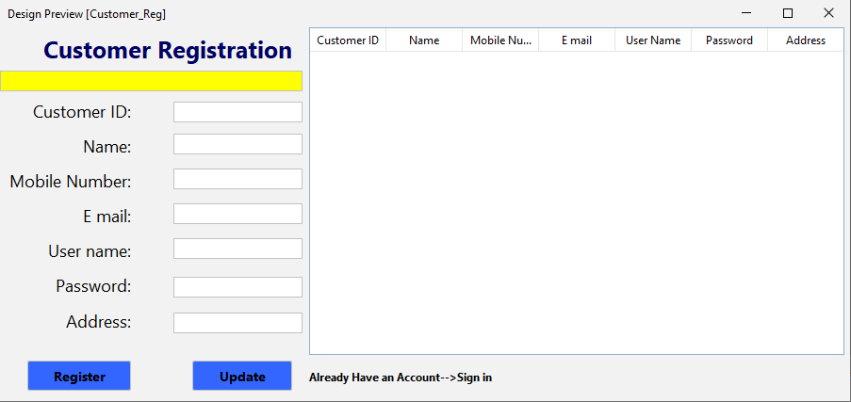

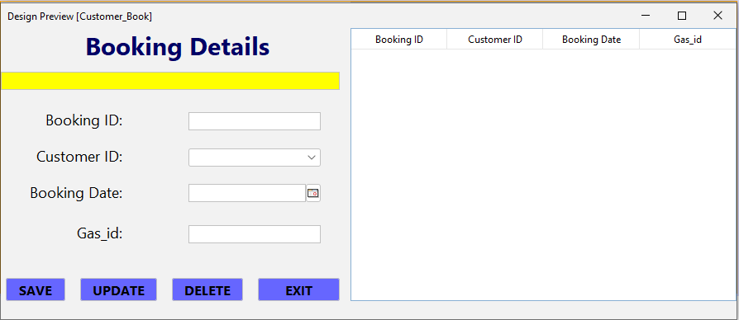

## 3.2 Hardware Interfaces

* Laptop/Desktop PC
* Core i3 Processor
* 4GB RAM
* 500GB

HDD Purpose of this pc is to give information when customers ask information about owners available etc. To perform such Action, it need very efficient computer otherwise due to that reason customers have to wait for a long time to get what they ask for.

## 3.3 Software Interface.

**Developing End**

* + Java
  + Front end: PHP my admin
  + Back end: Java
  + MySQL server- DB connectivity and management.
  + Adobe Photoshop and Illustrator- logo and other designing.

**Client End**

* Windows-OS or Android-OS

# 4. System Features

**Context Diagram**

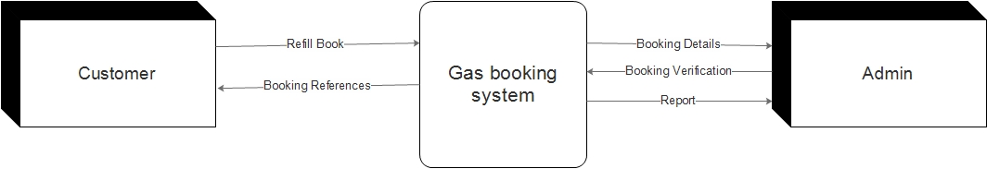

**DFD Level 1**

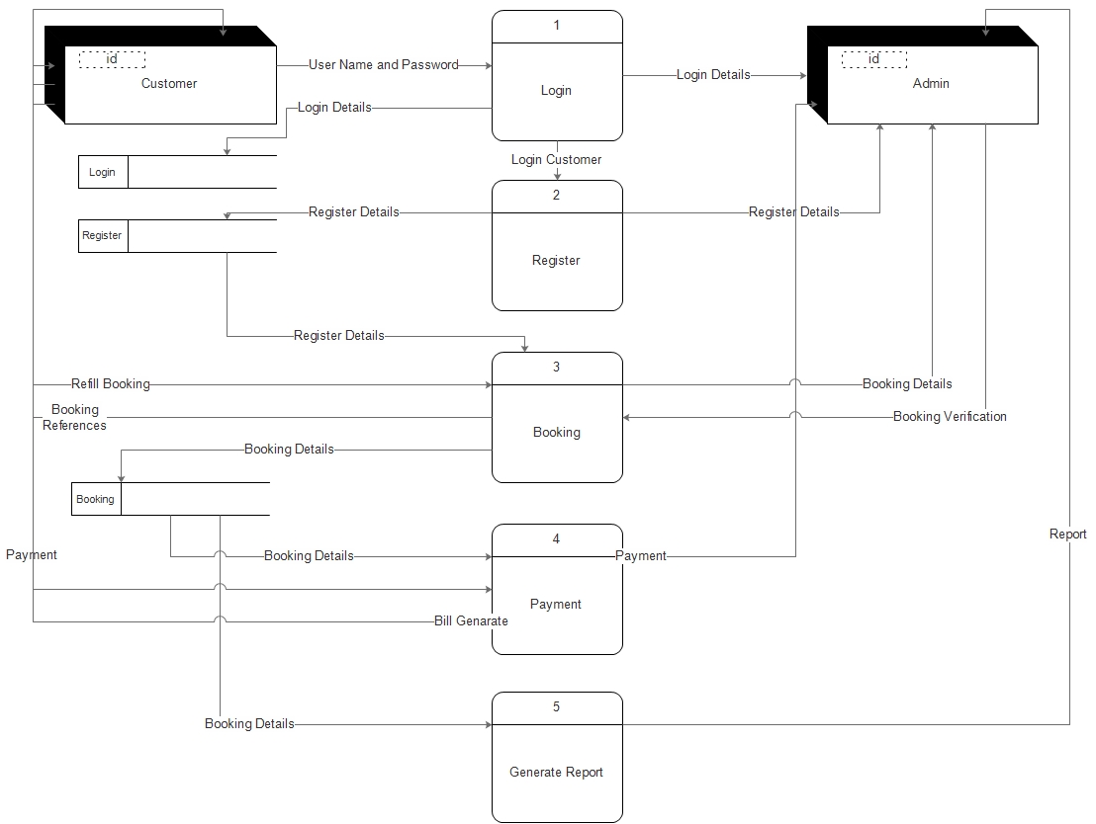

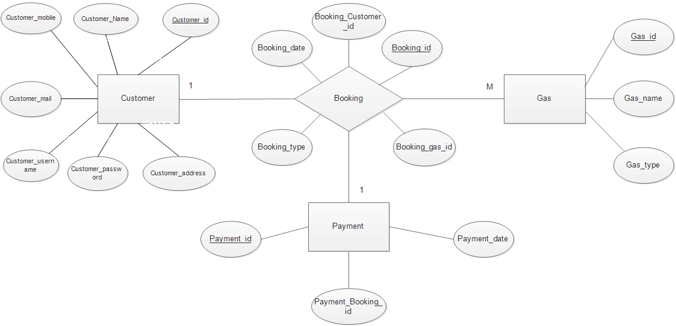**ER Diagram**

# 5. Other Nonfunctional Requirements

## 5.1 Performance Requirements

* No delayed actions in the system.
* User interface screen will response within 5 seconds.

## 5.2 Safety Requirements.

Maintaining another database in addition to the existing database in the system. (Manually)

## 5.3 Security Requirements.

All the administrative and data entry operators have unique logins so the system can

Understand who is login into the system right now no intruders are allowed except the system administrative nobody cannot change records and valuable data**.**

## 5.4 Software Quality Attributes

* **Availability:** The system shall be available all the time.
* **Maintainability:** System will be able to modify information, updates and fix problems of the system.
* **Usability:** Software can be used again and again.
* **Accessibility**: Administrators and many other users can access the system but the

Access level is controlled for each user according to their work scope.

* **Reliability:** The system always works to provide an effective service to the users of the system.
* **Stability:** The system has the ability to give each user the required output for the desired input.